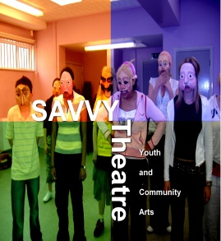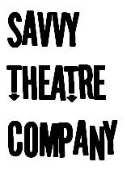

Application Form

SAVVY Theatre is committed to inclusion for all.
Please do let us know if there are any additional needs we should be made aware of, so we can best support you during the workshop.
If you require medication or 1:1 support with personal care, communication or travel, please bring someone with you.

PLEASE ASK SOMEONE TO HELP YOU FILL IN THIS FORM IF NEEDED.

YOUR NAME  ________________________________ | 
YOUR TELEPHONE NUMBERS  HOME:  MOBILE: | 
WE OFTEN TAKE PHOTOS AND/OR FILM. ARE YOU HAPPY FOR US TO USE YOUR PHOTO/VIDEO FOR PUBLICITY INCLUDING ON SOLICAL MEDIA?  YES NO | 

WHO SHOULD WE CONTACT IN AN EMERGENCY? | PERSON-1:  Full Name…………………………………………….  Relationship to you ……………………………..  Address…………………………………………….....  ……………………………………………………………..  Phone……………………………………………………..  Mobile…………………………………………………….  Work Number………………………………………….
PERSON-2:

Full Name……………………………………………….

Relationship to you………………………………..

Address………………………………………………….

Phone…………………………………………………….

Mobile……………………………………………………

Work Number………………………………………….

Do you have any specific health needs? (allergies, asthma, epilepsy, other medical conditions) | …………………………………………………………………
Epilepsy  Things to look out for!  What action needs to be taken If you have a seizure? | …………………………………………………………………  …………………………………………………………………
Do you use any mobility aids (wheelchair, sticks..) | Yes No
How will you travel to and from the workshop session  (please circle)  I am an independent traveller |   Yes No
What is the best way for you to communicate (Makaton, speech, communication book) | …………………………………………………………………  …………………………………………………………………
Any other details (I don’t like loud noises. If I’m feeling sad or angry I like to leave the room) | …………………………………………………………………  …………………………………………………………………
I have read and agree to the Code of Conduct | Yes No

